# **YouTube Trending Video Analysis – 2025**

## *****Introduction*****

This project analyses **YouTube trending videos for 2025**, focusing on factors influencing popularity. The study examines **global audience engagement**—views, likes, and comments—across countries. Insights reveal how **regional preferences, content categories, and creator strategies** contribute to trending success.

## *****Abstract*****

Authenticated YouTube data shows significant variations in engagement worldwide:

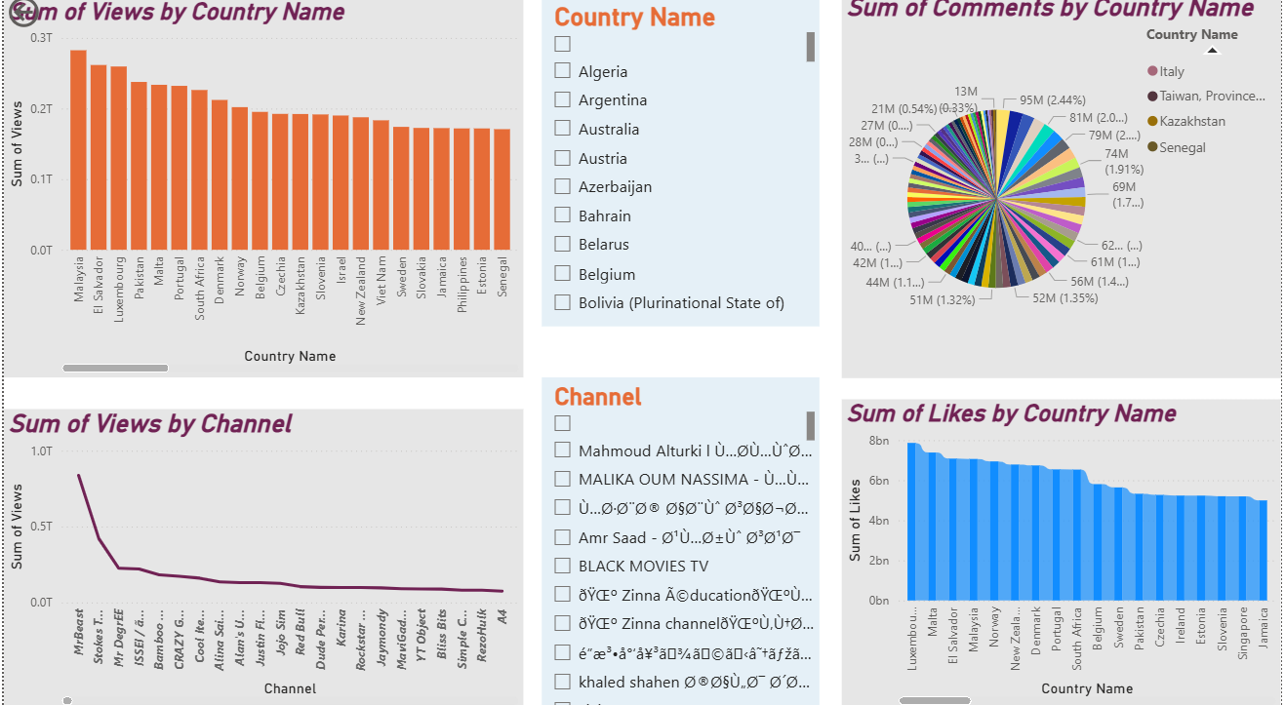

| **Metric** | **Maximum** | **Country** | **Minimum** | **Country** |
| --- | --- | --- | --- | --- |
| Views | 282,544,372,568 | Malaysia | 7,106,972,504 | Japan |
| Comments | 94,584,744 | Panama | 9,925,719 | Senegal |
| Likes | 7,863,663,067 | Luxembourg | 258,766,764 | Japan |

**MrBeast** is identified as the top-performing channel globally. These findings highlight how **content type, culture, and creator influence** shape trending dynamics.

## *****Most Watched Categories (September 2025)*****

## 

1. Education and Learning
2. Entertainment
3. Music
4. Gaming
5. Others – Cooking, Politics, Lifestyle

Most users spend **2–5 hours weekly** on YouTube, indicating its dual role as a source of **education and entertainment**.

## *****Tools Used*****

* **Microsoft Excel** – Data cleaning, sorting, tabulation
* **Power BI** – Visualization and dashboards

## *****Steps Involved in Project*****

1. Selection of topic – “YouTube Trending Videos 2025”
2. Data collection – Google Form for primary data
3. Secondary research – Global statistics from Google
4. Data preparation – Cleaning and organizing in Excel
5. Visualization – Power BI dashboards for insights

## *****Key Observations*****

* **As per the KEPIOS Feb2025 report, on YouTube Ad Reach Audience,**

**India** is the most favourable region for YouTube engagement and advertising. 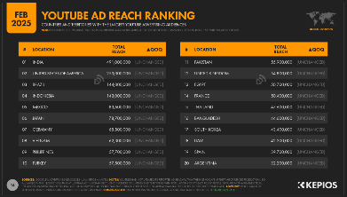

**25–34-year-old males and females** are the most active YouTube users globally.

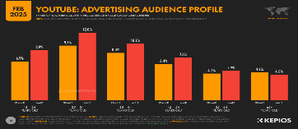

## *****Conclusion*****

YouTube continues to dominate digital media consumption in 2025.

* Countries like **Malaysia and Luxembourg** show extremely high engagement.
* While **India** remains key for advertisers.
* **Educational and entertainment content** attracts the largest audiences, confirming YouTube’s dual role as a **learning platform** and a **source of entertainment**.
* Age group 25-34 years are most active YouTube user.